**

**Phoenix125PrusaSlic3rColorScript**

**Thank you for checking out my simple PrusaSlic3r M3D Crane Quad tool!**

* ***NOTICE! My programs written in AutoIT often get flagged by Windows Defender as a virus.***
* ***To continue, add it as an exception. Feel free to analyze the source code and compile yourself.***

**Features**:

* Free Open Source program.
* Used for automatic post-processing of multiple extruder (color) G-codes for M3D Crane Quad.
* Simple function: Comments out all T Codes from. gcode files.
* Logs all changes into a log file.
* Creates a backup of the original G-code.
* Two modes:
  + Command line for automatic post-script processing
  + Executable for manually processing files.

**Installation**:

**1. Prepare PrusaSlic3r to add color changing codes by either method below:**

* *Import the included PrusaSlic3r Config.ini*

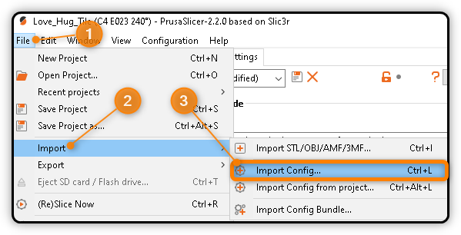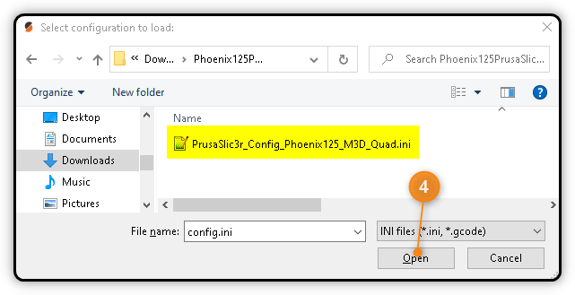

* ***OR*** *Use your existing profile and have PrusaSlic3r add the color changing codes*
  + *Enter the following G-code into the Tool change G-code Custom G-code section of Printer Settings*

{if next_extruder == 0}M567 P0 E1.00:0.00:0.00:0.00

{elsif next_extruder == 1}M567 P0 E0.00:1.00:0.00:0.00

{elsif next_extruder == 2}M567 P0 E0.00:0.00:1.00:0.00

{elsif next_extruder == 3}M567 P0 E0.00:0.00:0.00:1.00

{elsif next_extruder == 4}M567 P0 E0.50:0.50:0.00:0.00 ; Example of mixing

{elsif next_extruder == 5}M567 P0 E0.00:0.00:0.50:0.50 ; Example of mixing

{endif}

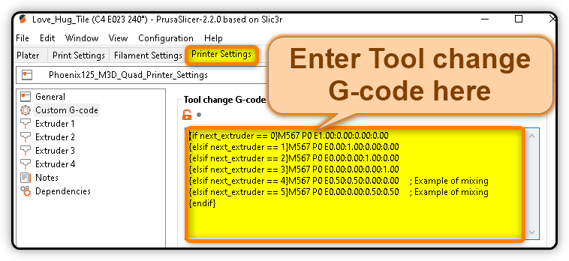

Adjust the extruder ratios (color blending) by adjusting the M567 P0 E[0]:[1]:[2]:[3] flow rate percentages in the code.

* Create as many virtual extruders as desired for your print by adding more “elseif next_extruder” lines
* Each “0.00” controls the flow rate of the corresponding extruder.
  + Ie. M567 P0 E1:1:1:1 would run all four extruders at full speed, extruding 4x as much filament
* In the included example, extruder 4 (a “virtual” extruder) will mix 50% each of Filaments 0 and 1

2. Enter the file location for the included Phoenix125PrusaSilc3rColorScript.exe file:

* This will run the included program automatically after you export your G-code.
* PrusaSlic3r adds T codes for each color change. The M3D Quad does not accept these T codes.
* The Phoenix125PrusaSilc3rColorScript program simply comments out all T codes.

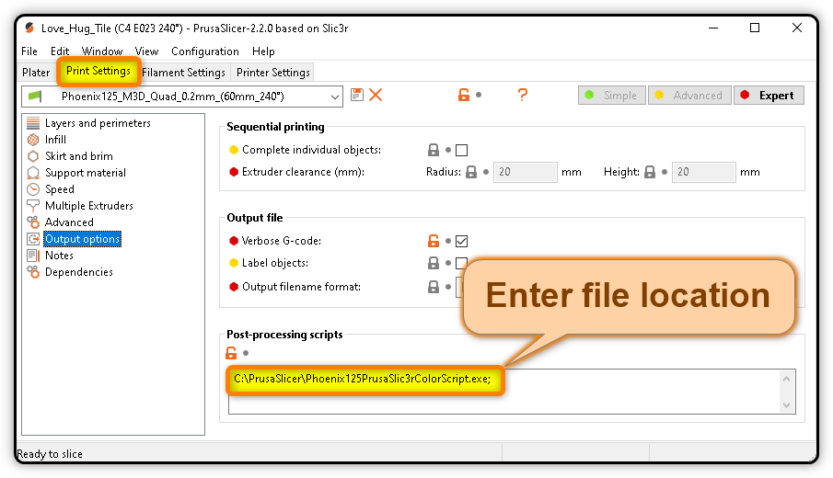

3. Import your STL, make any changes, and Export G-code

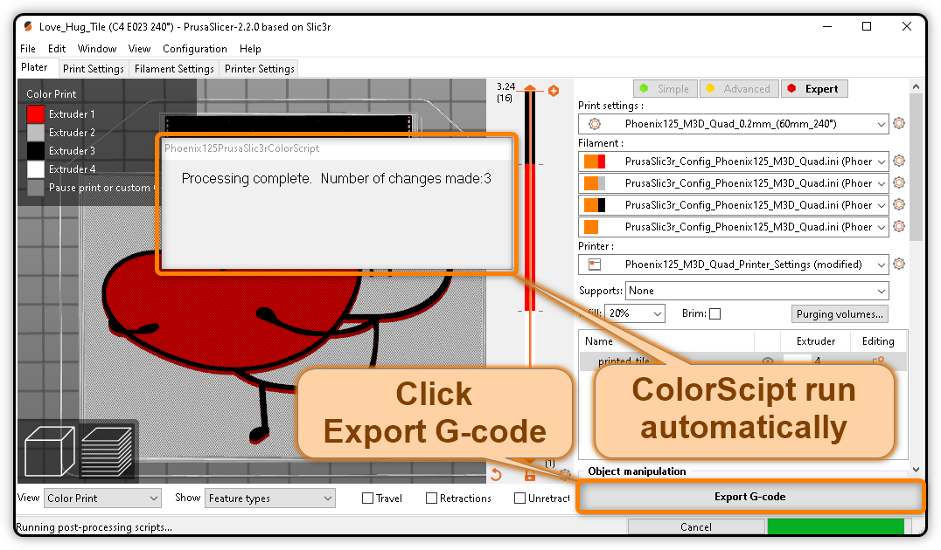

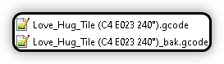4. You’re done! Your G-code file is ready to print!

**Links**:

Download PrusaSlic3r: <https://www.prusa3d.com/drivers/>

Download Phoenix125PrusaSlic3rColorScript: <http://wwwphoenix125.com/share/PrusaSlic3r/Phoenix125PrusaSlic3rColorScript.zip>

GitHub Source Code: <https://github.com/phoenix125/Phoenix125PrusaSlic3rColorScript>

Developer website: <http://www.Phoenix125.com>